# GUI Design

### Main Menu

Play Game – allows user to start the game

High Scores – check previous high scores

Exit

### Controller

Connect/Disconnect – connects to a game server

Button 1 / 2 | Thumbsticks – Player interaction

### Controller Mockup

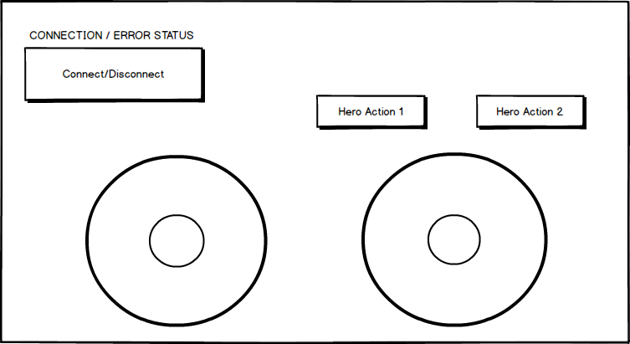

### Main Menu

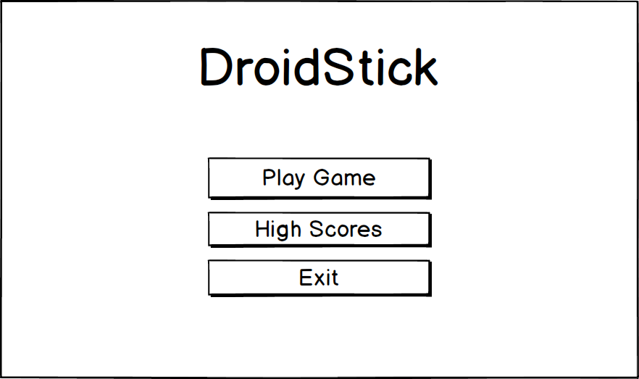

### Gameplay HUD

